Purpose

The purpose of the analysis was to be able to organize data and to visualize Louise’s launch campaign to showcase a Kickstarter play.

Analysis

To do this project, Microsoft Excel was used to create Pivot Tables, Pivot Charts, use formulas, and line graphs to analyze data to determine the possibility how successful Louise’s plays will be. During the data analysis, there were no difficulties, but there were challenges encountered. Some functions and formulas that were used from the files could have caused some challenges in the tables and outcomes data. Figure 1 and 2 both demonstrate outcomes based on goals and launch dates. Based on the data, we can see the lower the goal, the higher the success, and that majority of the success was in May.

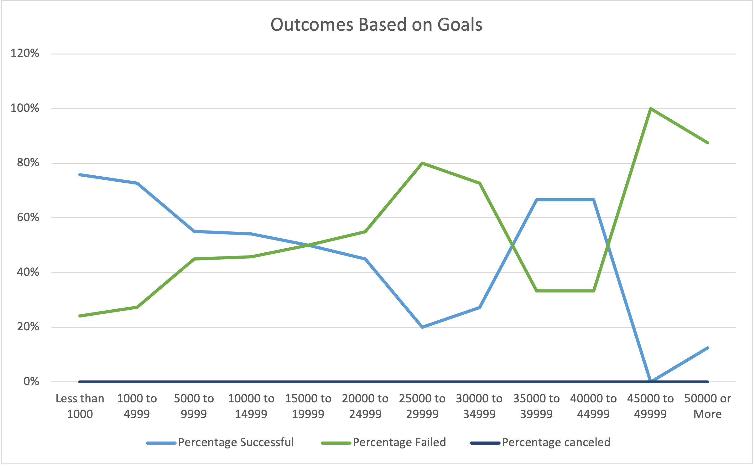

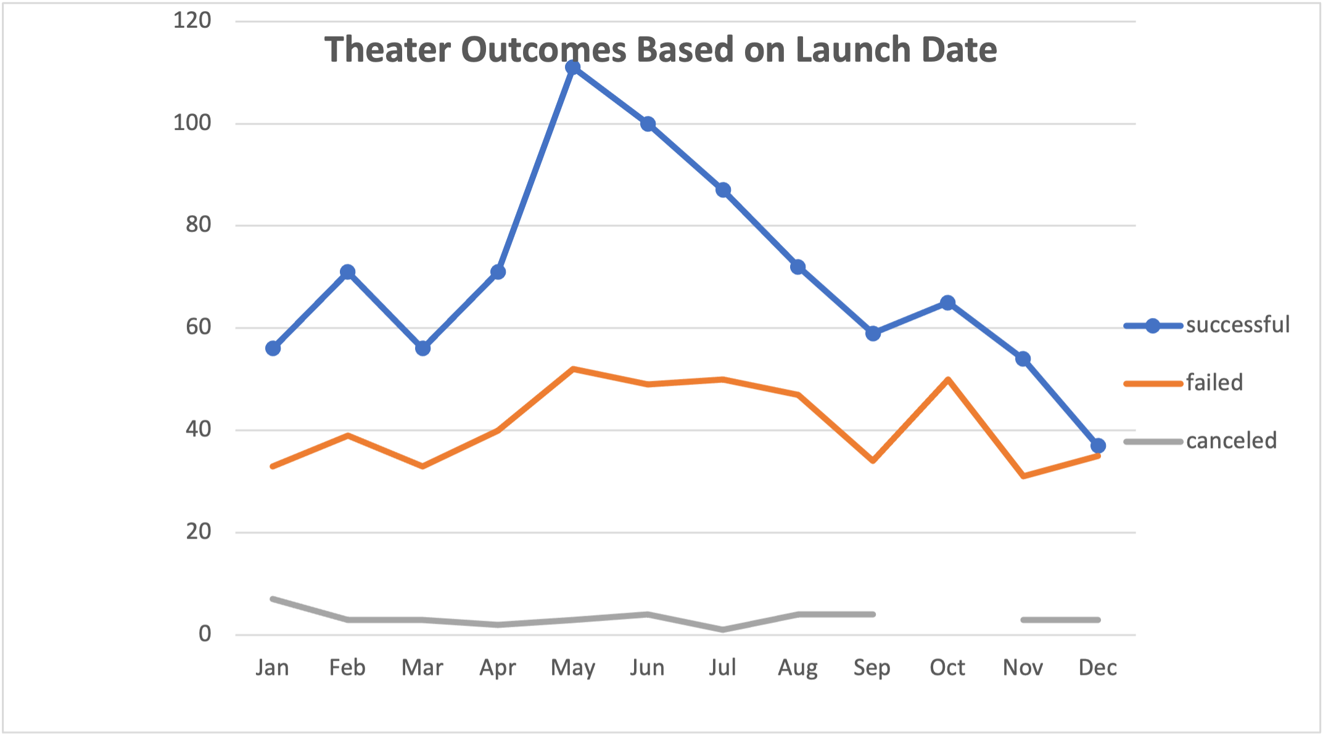

Conclusion

Based upon the data from Louise’s plays, May was the best projected month for Louise as far as the outcome for the play due to May having the highest success rate. Based on the data, the Spring time is best to launch a play because as we can see, during the winter months, the failure rate was higher in those months. Based upon the goals, the highest percentage successful was between 35,000-45,000 for the total projects from Louise. If the goals are lower, that means that the success rate will be higher.